A Narrative About the Clean Energy Opportunity Act (CEOA)

1. OPPORTUNITY
2. BASIC POLICY
3. SAVINGS
4. KENTUCKY CAN
5. LEFT BEHIND
6. ACTION

1. OPPORTUNITY: We have an opportunity to grow our economy and improve the lives of our people through clean energy solutions that lower energy costs and put people to work, building on clean energy progress being made right now from Paducah to Pikeville.

Clean energy solutions will help curb the steady increase in Kentucky’s energy costs – which are only projected to continue in coming years. Thousands of businesses and people across the state are already taking steps today to save energy and money. As a result, businesses in urban and rural areas are growing – many of which have signed on to support this bill because of the economic opportunities that would come with it.

Young people are getting trained in cutting-edge fields like energy efficiency retrofits and renewable energy manufacturing. Let’s make sure these students have jobs when they graduate. Homegrown jobs that can’t be exported. This bill would create 28,000 new jobs in the clean energy sector.

2. BASIC POLICY: The Clean Energy Opportunity Act would allow Kentucky to take modest but important steps in that direction. It will ramp up efforts like those already happening across the state to a very large scale by:
- setting modest energy offset and renewable energy production goals for most utilities over the next 10 years; (This is called a Renewable and Efficiency Portfolio Standard. As a percentage of our overall state portfolio, here are the targets)
- outlining energy savings targets that would have to come directly from improvements to the homes of low-income Kentuckians;
- and establishing contract terms and payment rates that utilities would pay in-state renewable energy producers. (These are called feed-in tariffs.)

3. SAVINGS: The bill is completely revenue neutral and it will save Kentucky’s families, farm and businesses money by curbing energy costs in the coming decade compared to doing nothing, a “business-as-usual” scenario.

4. KY CAN: We know that the bill will work in Kentucky and for Kentuckians. Kentucky has untapped clean energy potential and the know-how to use it today.

5. LEFT BEHIND: It’s important we act now. Kentucky is at risk of being left behind as nearby states, such as Ohio, reap the jobs and other benefits of similar clean energy policies already in place. In fact, 39 US states have renewable and energy efficiency standards in place.

6. ACTION: You can advance this conversation by co-sponsoring the bill and by learning more.

A Longer Version w/ Stories Included:

1. OPPORTUNITY: We have an opportunity to grow our economy and improve the lives of our people through clean energy solutions that lower energy costs and put people to work, building on clean energy progress being made right now from Paducah to Pikeville.

Clean energy solutions will help curb the steady increase in Kentucky’s energy costs – which are only projected to continue in coming years. Thousands of businesses and people across the state are already taking steps today to save energy and money.

For example….
- How$mart – local co-ops are making improvements to Eastern Kentuckians’ homes to help them save energy and enjoy a better quality of life. The loan for the work is returned through a pay-as-you-go approach, where residents get to pocket some of the savings on the monthly bill and use some of the savings to pay the loan back.
- Green Schools – Kentucky is nationally recognized for having more than 100 Energy Star schools, some of which generate renewable electricity on site! And, these schools are out-performing expectations and saving taxpayers thousands of dollars.

As a result, businesses in urban and rural areas are growing – many of which have signed on to support this bill because of the economic opportunities that would come with it.

For example….
- Alternative Energies, LLC, located in Danville is Kentucky’s only solar panel manufacturing company. They are staying afloat mainly because they sell panels to areas of Kentucky and TN that fall under the Tennessee Valley Authority utility company, which has many incentives for clean energy generation
- Home Energy Partners, operating in Richmond and Berea, KY, helps to empower people to make energy-saving improvements in their own homes. They survey homes and then provide trainings to teach homeowners how to do things themselves.

Young people are getting trained in cutting-edge fields like energy efficiency retrofits and renewable energy manufacturing. Let’s make sure these students have jobs when they graduate. Homegrown jobs that can’t be exported. This bill would create 28,000 new jobs in the clean energy sector.

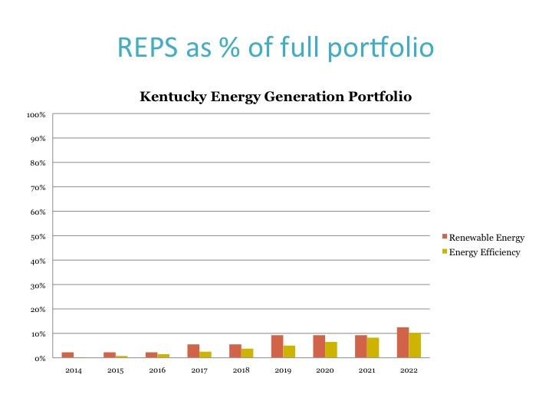
2. BASIC POLICY: The Clean Energy Opportunity Act would allow Kentucky to take modest but important steps in that direction. It will ramp up efforts like those already happening across the state to a very large scale by:

- setting modest energy offset and renewable energy production goals for most utilities over the next 10 years; (This is called a Renewable and Efficiency Portfolio Standard. As a percentage of our overall state portfolio, here are the targets – see graphic, left)
- outlining energy savings targets that would have to come directly from improvements to the homes of low-income Kentuckians;
- and establishing contract terms and payment rates that utilities would pay in-state renewable energy producers. (These are called feed-in tariffs.)

3. SAVINGS: The bill is completely revenue neutral and it will save Kentucky’s families, farm and businesses money by curbing energy bills in the coming decade compared to doing nothing, a “business-as-usual” scenario.

Kentucky’s electricity rates have risen 41 percent on average over the last 5 years. And they are projected to continue rising – at least 37% in the next decade - if we do nothing to change our current fuel sources. This bill will curb our energy costs compared to doing nothing, a “business-as-usual” scenario. (Synapse Economics)

Further, similar policies in other states have either not raised costs or raised them a fraction of a percent in most cases. (Lawrence Berkeley National Laboratory)

4. KY CAN: We know that the bill will work in Kentucky and for Kentuckians. Kentucky has untapped clean energy potential and the know-how to use it today.

For example…
- Improved energy efficiency could meet all of the growth in [Kentucky’s] energy demand predicted by 2017 (Kentucky Pollution Prevention Center).
- Kentucky has the capacity to more than double its existing energy supply from hydropower just by bringing offline, existing plants back online (U.S. National Laboratories).
- Kentucky’s solar energy resources are better than Germany’s, which has the greatest amount of installed solar capacity in the world

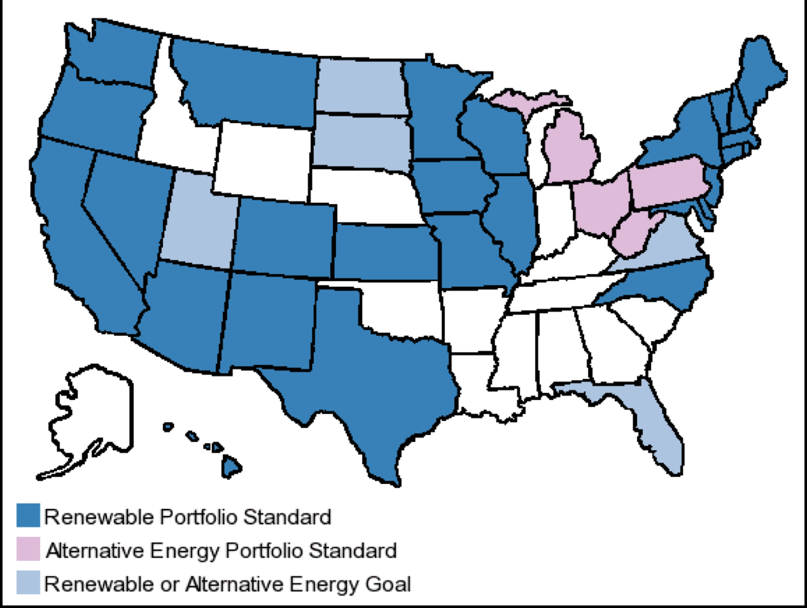
5. LEFT BEHIND: It’s important we act now. Kentucky is at risk of being left behind as nearby states, such as Ohio, reap the jobs and other benefits of similar clean energy policies already in place. In fact, 39 US states have renewable and energy efficiency standards in place.

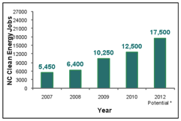
For example…
- North Carolina: Since passing a policy very similar to the CEOA in 2007, North Carolina has grown 12,500 jobs, billions in investments and 715 new businesses in rural and urban areas.
- Ohio: Since passing a policy very similar to the CEOA in 2008, Ohio has grown 9,000 jobs in direct renewable energy services and more than 70,000 jobs in solar and wind manufacturing.

6. ACTION: You can advance this conversation – here’s how:
- Co-sponsor the bill
- Learn more – what information do you need?

